Inventory Management System

- Class Design

- Product Class

- Purpose
Represents an individual item stored in inventory.

- Features
- Stores product details
- Tracks stock quantity
- Supports price and category mapping

- Attributes
Attribute | Data Type | Purpose
productId | int / String | Unique identifier for each product
productName | String | Name of the product
description | String | Detailed information about the product
category | Category | Category to which product belongs
unitPrice | double | Selling price per unit
costPrice | double | Purchase cost per unit
quantityInStock | int | Current available stock
reorderLevel | int | Minimum quantity before reordering
supplier | Supplier | Supplier of the product
status | String | Product availability (Active / Inactive)

Category Class

Purpose
Groups similar products together.

Features
- Organizes products
- Helps in filtering and reporting

Attributes
Attribute | Data Type | Purpose
categoryId | int / String | Unique category identifier
categoryName | String | Name of the category
description | String | Description of category
createdDate | Date | Category creation date

Supplier Class

Purpose
Stores information about product suppliers.

Features
- Manages supplier contact details
- Tracks supplied products

Attributes
Attribute | Data Type | Purpose
supplierId | int / String | Unique supplier ID
supplierName | String | Supplier company name
contactPerson | String | Supplier representative
phone | String | Contact number
email | String | Email address
address | String | Supplier location
status | String | Active / Inactive supplier

Inventory Class

Purpose
Tracks stock levels and product availability.

Features
- Stock updates
- Reorder level checking
- Inventory reports

Attributes
Attribute | Data Type | Purpose
inventoryId | int / String | Unique inventory record
product | Product | Product reference
stockIn | int | Quantity added to inventory
stockOut | int | Quantity removed
currentStock | int | Available stock
lastUpdated | Date | Last stock update date

User Class

Purpose
Represents system users.

Features
- Authentication
- Role-based access control

Attributes
Attribute | Data Type | Purpose
userId | int / String | Unique user identifier
username | String | Login username
password | String | Encrypted password
role | String | Admin / Manager / Staff
email | String | User email
phone | String | Contact number
status | String | Active / Disabled

Purchase Class

Purpose
Manages product procurement from suppliers.

Features
- Records purchases
- Updates stock levels

Attributes
Attribute | Data Type | Purpose
purchaseId | int / String | Unique purchase ID
supplier | Supplier | Supplier reference
purchaseDate | Date | Date of purchase
totalAmount | double | Total purchase cost
purchaseStatus | String | Pending / Completed
createdBy | User | User who made purchase

PurchaseItem Class

Purpose
Stores individual products in a purchase.

Features
- Item-level purchase tracking

Attributes
Attribute | Data Type | Purpose
purchaseItemId | int | Unique ID
purchase | Purchase | Purchase reference
product | Product | Purchased product
quantity | int | Quantity purchased
unitCost | double | Cost per unit
totalCost | double | quantity × unitCost

Sales Class

Purpose
Records product sales to customers.

Features
- Deducts inventory
- Tracks revenue

Attributes
Attribute | Data Type | Purpose
salesId | int / String | Unique sale ID
salesDate | Date | Sale date
totalAmount | double | Total sale value
paymentMode | String | Cash / Card / UPI
soldBy | User | Salesperson

SalesItem Class

Purpose
Stores items involved in a sale.

Features
- Tracks sold products

Attributes
Attribute | Data Type | Purpose
salesItemId | int | Unique ID
sales | Sales | Sales reference
product | Product | Sold product
quantity | int | Quantity sold
unitPrice | double | Selling price
totalPrice | double | quantity × unitPrice

- Customer Class (Optional but Recommended)

Purpose
Stores customer details.

Features
- Customer-wise sales tracking

Attributes
Attribute | Data Type | Purpose
customerId | int / String | Unique customer ID
customerName | String | Customer name
phone | String | Contact number
email | String | Email address
address | String | Customer address

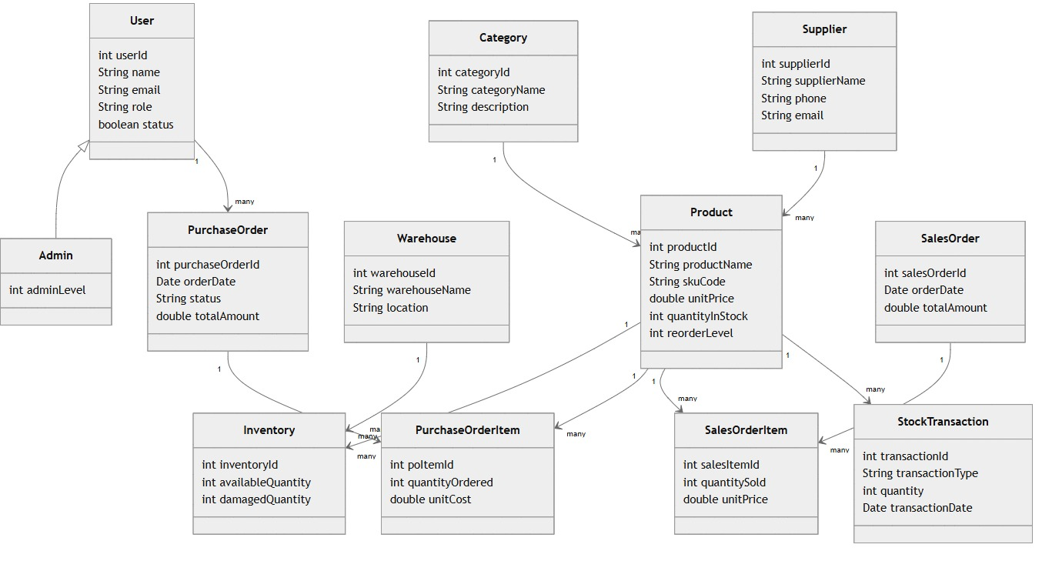

Admin Activity Diagram
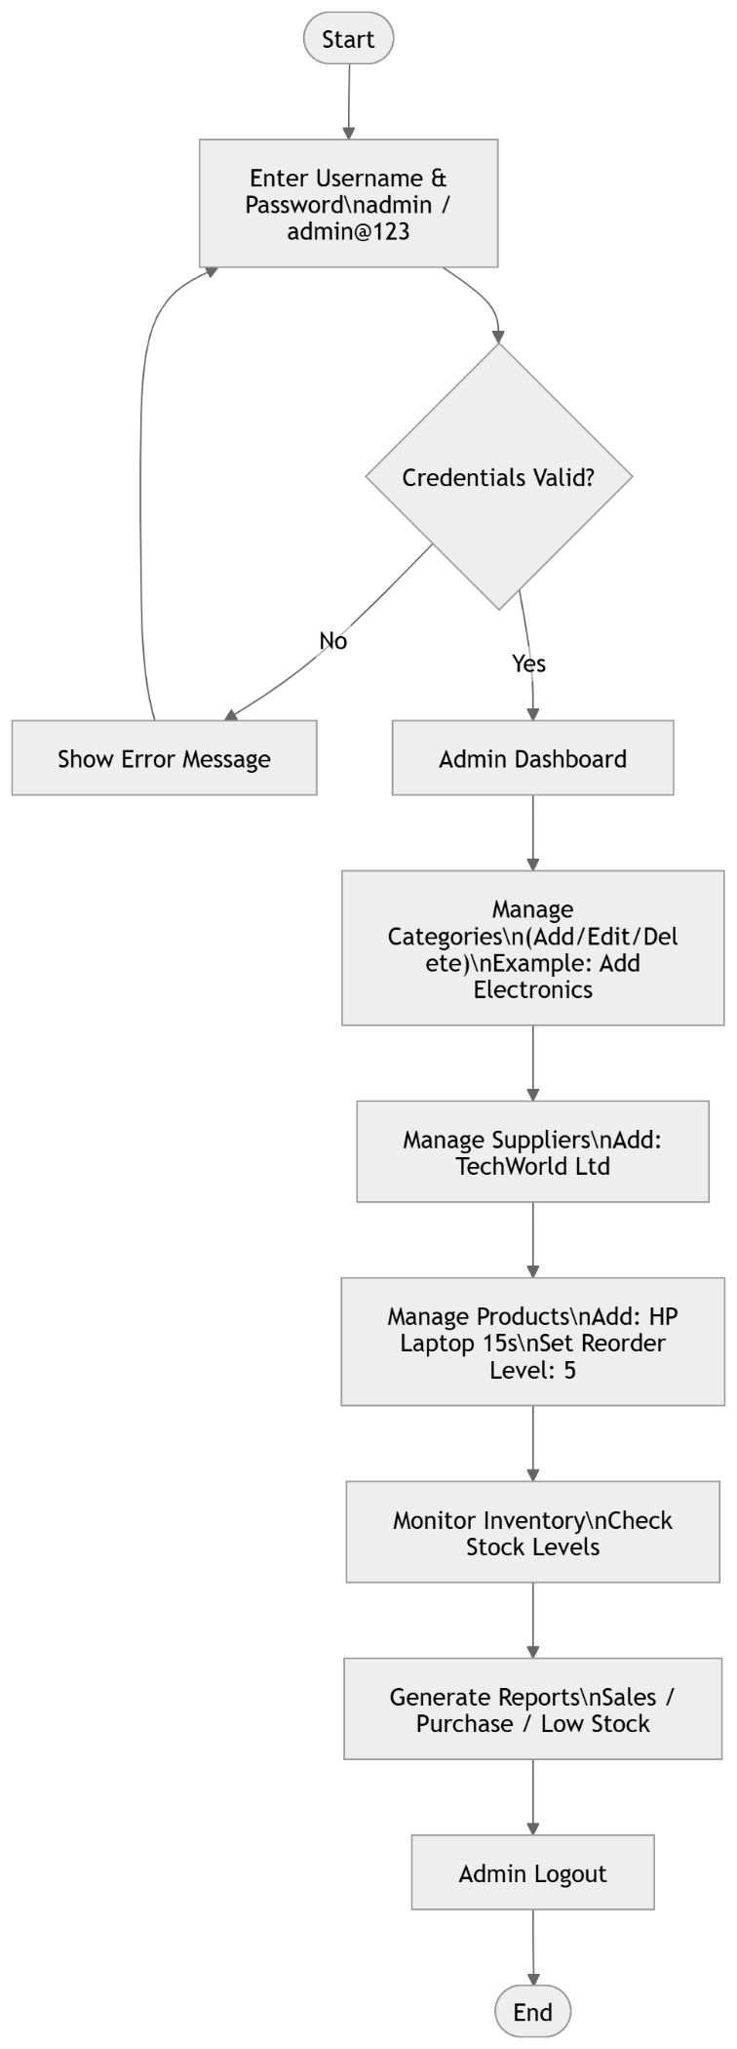
User Activity Diagram

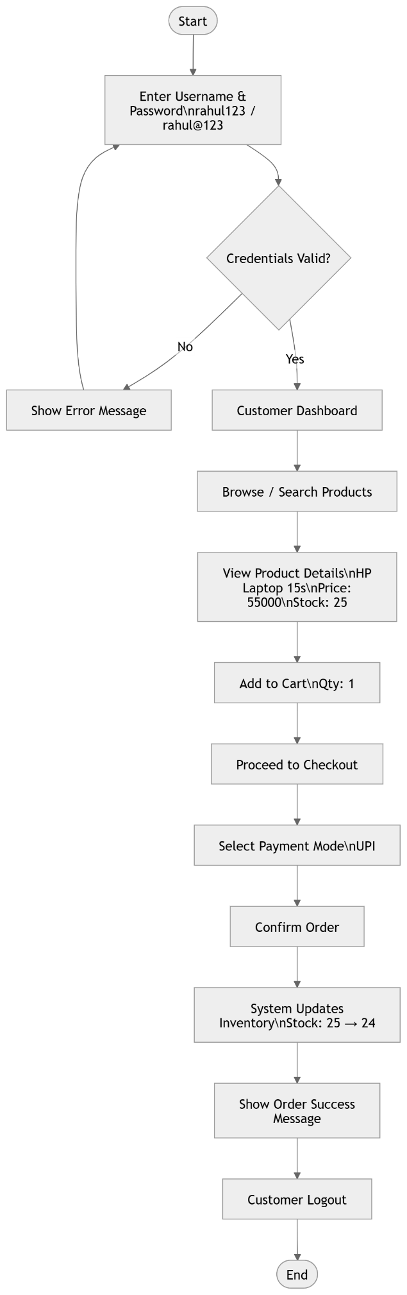
Table | Connected Table | Relationship
Category | Product | 1 → Many
Supplier | Product | 1 → Many
Product | Inventory | 1 → 1
Supplier | Purchase | 1 → Many
Purchase | PurchaseItem | 1 → Many
Product | PurchaseItem | 1 → Many
Sales | SalesItem | 1 → Many
Product | SalesItem | 1 → Many
Customer | Sales | 1 → Many
User | Purchase / Sales | 1 → Many

- Table Create Order (Line Wise Flow)

User
↓
Category
↓
Supplier
↓
Product
↓
Purchase
↓
PurchaseItem
↓
Sales
↓
SalesItem
↓
Inventory

